Proceedings of the 6th Undergraduate Research Forum, Faculty of Allied Health Sciences, University of Jaffna, Sri Lanka, 5th April 2024
Empower Healthy Aging with Health Literacy
While living longer than ever is a reality, living longer in a good health still remains a challenge. Because of the growing number of elderly population worldwide and particularly Sri Lanka, being the fastest aging country in South Asia, health care (HC) professionals increasingly confront providing HC services to vulnerable client groups, such as older people, persons with lower socioeconomic status, and with chronic illnesses. These client groups typically show decreased knowledge and motivation to access, understand, and apply health information for taking decisions concerning their own health – a state defined as Health Literacy (HL). Limited HL levels vary between 25-75% worldwide. Inadequate HL is linked to reduced usage of health care services, increased morbidity and mortality, and higher health care costs. Persons with limited HL require individual therapeutic and communication approach from their HC providers. To respond this demand, HC professionals need to acquire solid HL competencies during their higher education. The HL contents currently offered in the most HC study programs, are insufficient to provide high quality care adequately to persons with limited HL.
Therefore, in the HELPE* project we developed a HL educational program which promotes the HL competencies HC students. The methodology was based on scoping review and co-creation design including focus groups and teaching/ learning activities with the key stakeholders. Main results include: HL competency framework to ensure high standard scientific background for the teaching contents and six educational courses. The HL contents offer flexible integration in the HC curricula and are expected to increase the awareness of HL importance. The developed HL contents will be incorporated in the CAPAGE** project which aims establishing sustainable innovation capacity for modernization of Sri Lankan higher and professional HC education in Healthy Aging and Geriatrics through coordinated interdisciplinary approach.

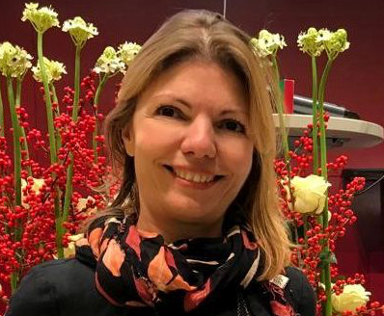

*Consortium HELPE Project “HEALTH LITERACY IN THE PHYSIOTHERAPY EDUCATION“ supported by the Erasmus+ programme of the European Union (2020-1-AT01-KA203-078086).
M. Christova¹, M. Handgraaf², C. Fernández³, A. Hagen⁴, J. Luiken⁴, P. Mäki-Natunen⁵, S. Paasu-Hynynen⁵, B. Jochamm¹, A. Arntz², C. Grüneberg². ¹Institute of Physiotherapy, University of Applied Sciences FH JOANNEUM Graz, Austria, ²Institute of Health, University of Applied Sciences, Bochum, Germany, ³Blanquerna School of Health Science, Barcelona, Spain, ⁴University of Applied Sciences, Utrecht, Netherlands, ⁵University of Applied Sciences, Jyväskylä, Finland.
**Consortium CAPAGE Project “Promoting academic and professional excellence in health care to meet the challenges of aging in Sri Lanka”, supported by the Erasmus+ programme of the European Union (101127234 -CAPAGE-ERASMUS-EDU-CBHE): Eastern University of Sri Lanka, General Sir John Kotelawala Defence University, Sri Lanka, JAMK University of Applied Sciences, Finland , Santa Maria Health School, Portugal, University of Applied Sciences FH JOANNEUM, Austria, University of Colombo, Sri Lanka, University of A Coruña, Spain, University of Jaffna, Sri Lanka, University of Peradeniya, Sri Lanka, University of Ruhuna, Sri Lanka.

